SUMO BOT

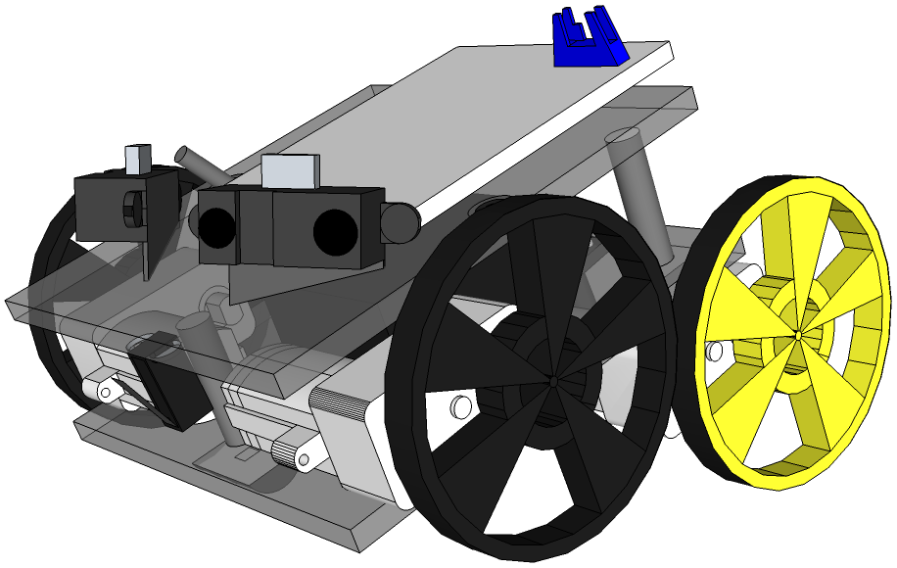

User Manual

Prepared By:

TEAM S.U.M.O.B.O.T.
Dear Fellow Aficionado of Robotics,

Thank you for buying your very own SUMO BOT.

The goal of this User Manual is to ensure that you get the most enjoyment out of your robot.

We, at Team SUMOBOT, believe that no one should be subjected to the boring activity of having to read Owner's Documentation from the beginning to the end, especially right after cracking open the shipping box, when all you want to do is to flip the switch and have your SUMO BOT begin to push .. well .. things!

We do, however, suggest that you quickly peruse the PREPARATION section, to make sure that you can begin to fully enjoy the robot right out of the box.

Once you've quenched your initial SUMO thirst, we invite you to visit the remaining sections of this text. In the Use of Existing Functionalities chapter, you will discover the full extent of this SUMO BOT's capabilities. In the Extension of Functionalities section, we'll tell you how you may teach your BOT new tricks by changing its default programming, and by swapping various hardware components. The Troubleshooting chapter will tell you how to recover from most common problems ( usually hardware-related ). Finally, the Maintenance portion will tell you how to keep your robot operational ( in tip-top shape ).

Our Technical Support Department is always available to answer your questions. You may contact our specialists by e-mail at: tech@sumobot.net

If you prefer to phone us, you may reach us at 1-888-SUM-OBOT . Our specialists are available 24 hours a day, 7 days a week.

Table of Contents
1 Preparation 3
2 Use of Existing Functionalities 4
2.1 Powering-On / Powering-Off 5
2.2 Adjusting IR Range Sensors 5
2.3 Deployment Procedure 5
3 Extension of Functionalities 6
4 Troubleshooting 8
5 Maintenance 9
6 Warranty 10

Preparation

By now you've opened the box in which we shipped the robot to you. Enveloped in a protective antistatic bag, and immobilized in blocks of styrofoam is your fully-assembled SUMO BOT. To remove the hardware from its cocoon, pull the extruded polystyrene foam blocks apart, touch a grounded metal object ( a kitchen faucet will do ) to drain any excess static electricity from your body, and then remove the robot from its bag.
Now, let's go through a checklist, to make sure that you received all the parts. Our Quality Control is next to none, but it's always good to check.

- pre-assembled SUMO BOT ( with pre-installed battery pack )
- power transformer, ie. charger brick
- user-manual
- programming cable with USB connector
- battery pack ( 6 x AA NiMH batteries are included and pre-charged )
- DVD with software ( WinAVR, AVR Studio 4, Pony Prog )

In the unlikely event that any of the above components could not be located in the shipping box, please contact us, we will immediately send you any missing parts by expedited mail.

To prevent robot's accidental activation during shipping, the battery pack is equipped with an insulating tab that prevents unintended discharge of stored energy. Reach in the robot's rear, locate a bright red plastic tab, attached to the battery pack, that says 'pull me', and do exactly what it says, pull it toward you until it is fully dislodged. You may throw it away; it will not be need again.

At this point, the robot's electronics should be energized. On the PCB, locate a push-button marked as 'Self-Test'. Ensure that the robot is on a flat, level surface and that it has at least 30 cm of clearance in all directions. Push the 'Self-Test' button, then release it. The robot will go through a general self-test. It will test its main circuit, charge level of its battery pack, as well as its sensors and motors. Upon a successful completion of the test, a green LED next to the 'Self-Test' button will light up. If its companion red LED becomes lit, please contact us, we will send you a replacement pre-assembled SUMO BOT immediately.

Let's have a word about your SUMO BOT's Operating Conditions. The usual requirements apply: keep your robot dry, operate it on a level, clean surface, ie. not in a sandbox, don't operate your Van de Graaff generator in a close vicinity of your robot, don't step on it, don't kick it. If you follow your common sense, you'll be okay.

Use of Existing Functionalities

The hardware and software of your SUMO BOT have been selected to allow it to participate in the sport of Robot-Sumo, where two robots attempt to push each other out of a circle. Sensing the opponent is done using IR range sensors. Ring-boundary detection is done using opto-reflector IR edge sensors. Locomotion is accomplished through rolling motion using wheels powered by four DC motors.

Powering-On / Powering-Off

To power ON the robot, actuate the mechanical lever ( from OFF to ON ) of the toggle switch, installed on the main circuit board, mounted on the top chassis. Note that after doing so, the robot will wait 5 seconds and then it will begin to battle. For that reason, before activating the toggle switch, have the robot sitting on a flat surface, or hold it in a way that allows for its wheels to rotate.

To power OFF the robot, flip the toggle switch from ON to OFF position. This will cause an immediate shutdown of all of robot's functions.

Adjusting IR Range Sensors

If it is the case that the height of the opponent robot warrants adjustment of your IR range sensors, you may pivot the IR range sensors so that they precisely aim at the approaching opponent.

Deployment Procedure

Deploying the robot for battle consists of: placing it in the battle ring, facing away from the opponent; actuating the toggle switch from the OFF to the ON position; and moving away from the battle ring; the robot is pre-programmed to battle after a delay of 5 seconds.

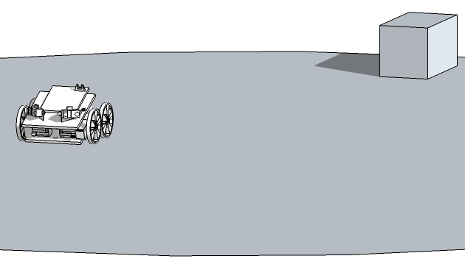
Figure 2.1: Artist's rendering of initial positioning of the robot in the SUMO arena

Extension of Functionalities

Capabilities of the SUMO BOT that you purchased can be extended through both hardware & software due to a modular design of the robot.

The PCB with installed microcontroller chip ( ATmega8L , providing 8K of self-programming flash memory) can be replaced with faster microcontrollers ( with more in-system programmable flash ) from the AVR 8-bit RISC family.
A faster microcontroller with more in-system storage allows the owner to modify the original programming by writing more complex programs.

Using the supplied AVR Studio 4 IDE (Integrated Development Environment), together with WinAVR Compiler Suite, and PonyProg Device Programmer software, you'll be able to easily write, debug, and compile C programs, to control your robot.
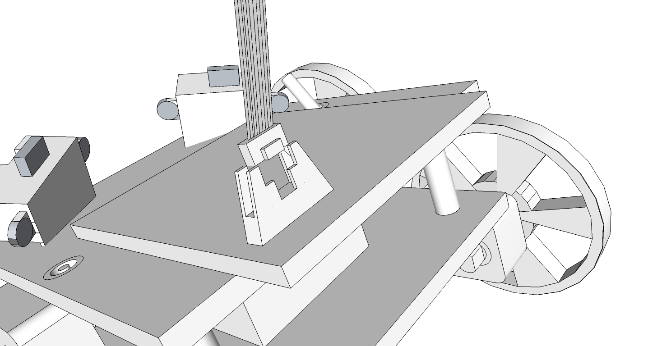
Figure 2.2: Artist's rendering of ISP ( In-System Programming ) cable being inserted into its designated socket.

To load additional software onto the microcontroller, please follow these steps:

Step 1: (Optional) Using AVR Studio, compile the code that you want to load to the chip.

Step 2: Run 'ponyprog.exe', go to Device, in the AVR micro submenu select Atmega8.

Step 3: Go to File, Open Device File, find the binary file you need to load onto the chip. If you compiled your own code, then the binary file will be found in the “default” folder of your AVR studio project folder. The code will appear in hex format in the 'ponyprog.exe' window.

Step 4: Go to Setup, then Interface Setup; make sure the I/O port setup is set to SERIAL, press OK.

Step 5: Plug your interface cable into the USB port of your computer.

Step 6: Plug the other end of the interface cable into the robot's ISP port.
Step 7: Turn ON your SUMO Bot.

Step 8: In the Command menu of 'ponyprog.exe', click on 'Write All ( Ctrl-W ).

Step 9: The binary code will now be transferred to the Atmega chip that controls your robot.

NOTE: A variety of pre-made routines in binary and C source code format can be downloaded on the SUMO Bot web site. All code is Open-Source and can be modified at will using the AVR Studio software to adapt it to your own robot.

Troubleshooting

Question | Answer
I moved the toggle switch to the ON position, but the robot failed to move. | Did you attempt a Self-Test? If it failed, try recharging the batteries.
Battery pack has been fully charged. The robot activated properly, but within a few minutes, it slowed down and then it stopped moving altogether. | Try replacing your existing batteries with a fresh set. NiMH cells usually last for 600+ charge cycles, but they could have experienced a premature failre.
The robot can't find the opponent. What's wrong? | Make sure that connectors of both IR range sensors are firmly plugged into their headers. If the problem persists, contact our Technical Support.
One of the motors stopped working. How do I fix it? | Verify continuity of all connecting jumper wires.
There is a smell of burning insulation coming from my robot's motors. Is that bad? | Yes, that's bad. You're overloading your motors. Stick with opponents of your own size & mass.
The robot is “twitching” or spinning in place. What happened? | Look under the robot's body. Locate the opto-reflector IR edge sensor. If it is obstructed by debris, clean it and try again.
I pushed the Selft-Test button. There was no response. Neither the red, nor the green LED lights up. What now? | Make sure that the battery pack connector is firmly attached. Make sure that the batteries are fully charged.

Maintenance

To ensure that your SUMO BOT does not run out of power during battle, remember to recharge its NiMH batteries before the fight. Compared to lithium-ion batteries, the volumetric energy density of NiMH batteries is lower, and self-discharge rate is higher. Never substitute a NiCd charger for the one supplied with your SUMO BOT. Disregarding that last instruction could result in damage to the batteries.

When you're not using your robot, you may store it in the supplied antistatic bag. The NiMH batteries can be stored for extended periods of time in either charged or discharged state. Make sure that they are not exposed to extreme temperatures. Recommended storage temperatures for NiMH cells are in the range of -20 C to +35 C with relative humidity being kept at around 50%. It is recommended that the batteries be recharged once a year. After several months in storage, your battery pack should be recharged before use.

Prior to deploying your SUMO BOT in battle, we suggest that you first run a 'Self-Test'. This will check the charge level of the battery pack.

Most manufactures quote NiMH batteries as good for an average of 600 to 700 charging cycles. If you wish to “play it safe” during a Robot-Sumo competition, you should replace your cells with a “fresh” set of batteries after 600 charging cycles. Numbering the batteries is a good way to make sure that you never mix up old and new batteries.

To improve the grip of tires on the ground, periodically clean them with a microfiber cloth. This will pick up any dust and increase their traction. To clean off dust from the circuit board, use a can of compressed air to blow it away.

Warranty

This product is covered by a one year warranty on parts & labour. Should any failure of any component ( other than the batteries, which are guaranteed to retain at least 80% of their nominal capacity for at least 600 charge cycles ) occur during the period, please send back your robot to our authorized service center, where our agent will replace the robot ( no questions asked ). This warranty will, of course be null & void in the event of willful neglect & abuse of the robot..

If you have any questions regarding this product, please contact us at these coordinates :

S.U.M.O.B.O.T. Ltd.
1 Finite Loop
Cupervino, CA 90210
Toll-Free: 1-800-SUM-OBOT
Web Site: www.sumobot.net
Tech Support Email: tech@sumobot.net
Sales Email: sales@sumobot.net

